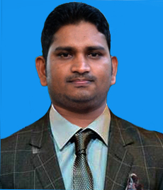

CURRICULUM VITAE

GANESH PIRATHEEPAN ,
KUNDUMADU,
POTTUVIL. - 09
TEL. 077 2098980 Skype-deep20124
Email. Piratheepandeep@gmail.com
SRI LANKA.

PERSONAL DETAILS:

Full Name :- GANESH PIRATHEEPAN
Name With Initials :- G. PIRATHEEPAN
Permanent Address :- KUNDUMADU, POTTUVIL – 09
Age :- 32
Date of Birth :- 1982.03.14
N.I.C :- 820742591V
Sex :- MALE
Civil Status :- MARRIED
Nationality :- SRI LANKAN TAMIL
Contact no :- 077 2098980
Distinct :-AMPARA

EDUCATION QULIFATION :-

2002 O/L DECEMBER AK/ POTTUVIL CENTRAL COLLEGE
2005 A/L April AK/ POTTUVIL CENTRAL COLLEGE
2010 Diploma In Microsoft Office

WORKING EXPERIENCE :-

- 2 Years Experience as a Follow up Messenger at Dubai
- 2Years Experience as a Supervisor at Arugambay Hotel Pottuvil
- 5 Years Experience as a Maga Engineering Office Assistant and Bill Clark
- 2 Years Experience as a Clark Inrenational Federation Of Red Crocc

SPECIFIC SIKLLS POSSESSED :-

- Good communication and Interpersonal skills.
- Knowledge in filling and preparing documents.
- Work hard to meet a task within a given time.
    - Analytical ability
    - Excellent leadership ability
- Good in public relation.

LANGUAGES :-

- Good in English, Sinhala and Hindi Excellent in Tamil

COMPUTER LITERACY :-

- Well Knowledge in Internet & E-mail
- Good working knowledge in Adobe Photoshop
- Good working knowledge in MS OFFICE package.

I do herby certify that above particulars are true and correct to the best of my knowledge and believe.

Date : 2015.12.27 Signature of Applicant

G. Piratheepan

